Gym Crowding

Live Count Tracker Team

Team 2 - Social

Stage 4 Narrative

Information Technology Informatics 210 - Section 04

Team:

Devan Desai, Deyondre Louis, Electra Dorziotiz, Huzaifah Majid

Project name: Crowd Meter 2.0

Group name: Live Count Tracker Team

Focus area: Social Problem

# Elevator Pitch

Have you ever been to the gym only to see your worst nightmare? bodybuilders to your left, weightlifters to your right, and worst of all, they are all occupying the machines you wanted to use! Well, stress no more!

With this new Crowd monitoring app that we are creating, users will be able to check the amount of people occupying a gym of their choice.

You will never have to worry about asking that huge guy “how many sets you got left?” You will never have to worry about feeling insecure as a beginner. And best of all, you will never have to waste your time by leaving for the gym during crowded hours!

Not convinced? Our app even allows you to track all your stats through the year! We all have heard of spotify wrapped…. But you've never heard of reps wrapped!

Reps wrapped enables users to keep track of their total reps, weight, and time. Nothing more satisfying than quantifying all that progress! Join us in facilitating beginners at our gyms so we can see everyone prosper.

By adding this simple feature to the app, we predict an increase in memberships and activity at the gym.

# Project Description

Enhancing the “Crowd Meter” feature in the planet fitness application to enable users to track live count of people.

# Who We Are

We are an internal group stemming from Planet Fitness’s Crowd Meter Group. The goal of our project is to add another feature that the company can benefit from. Our group consists of three teams. The first team consists of leaders/managers. The main goal of the leaders and managers is to make sure that quality content is being produced within the time frame given by company managers. The second group is an analytical group that helps with market research and business analytics that will be the key to adjusting factors for the better. The last group consists of people from our production team. They will be responsible for handling the innovation of Information Technology to help us roll out our project with ease.

We are a group of interns looking for a call back after our semester with Planet Fitness. Huzaifah was voted group leader since he portrayed good communication skills with the group and it is apparent he has prior experience in leading a group of people to a certain goal. Devan was appointed project manager due to his ability to become familiar with the project to the point where he knows what everyone needs to do in-order to meet the end goal. This is important because if he is managing the project, he should be able to foresee any hardships/complications that we may encounter. It also makes sense to have Devan be the project manager since he already has prior experience with a similar project. Lastly our documentation/presentation manager is Electra. She has a passion for her field and can communicate extremely well. She is assigned with the task of making all aspects of the project presentable to the audience.

Huzaifah and Electra will lead the team in market research and business analytics. Their prior experience in an entrepreneurship class gives them the necessary skills to conduct professional research and conduct advanced analytics to meet the team’s needs.

Deyondre was brought on to the team because of his advanced skills in photography and visual effects. Deyondre will be the main man when it comes to designing, optimizing, and adjusting the application interface and information technology products that we will use in order to meet the project requirements.

We are just getting started with the project and continuously getting to know each other more. As the project progresses, we hope to further identify individual weaknesses and strengths so we can have a better understanding of who should contribute to the project in what way.

# Preliminary Plan

## Team Assignments

#### Team Leadership and Management:

**Team Leader (Huzaifah) -** A leadership position is one that comes with great responsibility, as does a management position,however, managers govern with a set of rules, while leaders build the team more freely[1]. Leadership is different from management and the terms should be used accordingly. As team leader, Huzaifah is assigned with the task of bringing the team together and keeping them motivated to finish the project with quality and time being the main factors. The initial stages of team leadership were portrayed at the start of the project. Huzaifah helped the team get accustomed to one another through a quick ice breaker session where everyone learned a couple interesting facts about the rest of the team members. Additionally, Huzaifah is responsible for setting up meeting dates/times and making sure the meeting venue has been properly accommodated. Once the meeting commences, Huzaifah makes sure that all important discussion topics are thoroughly communicated between the team members and everyone has a clear idea of what the upcoming goals are before the next meeting. Identifying goals and evaluating progress are key to our team's success[2].

**Project Manager (Devan)** - Responsible for Planning, Organizing, and Managing the resources, some of the task that the project manager does would include, to define the project scope, manage the gantt chart, and making sure that everything is running on time.The project manager is the one who takes accountability if the project ends up failing or succeeding. Devan makes the perfect project manager for the team since the project idea was his. The project manager should have knowledge of all the different aspects to the project and Devan showcased this at the first meeting. Devan came prepared with the project idea and a rough presentation of how the project could be implemented. The team was confident in Devan’s idea and decided to proceed with his plan.

**Presentation/Documentation Manager (Electra)** -Responsible for making sure that the presentation has all of the correct information added to it and is ready to present, and adds necessary information to the presentation as well. In addition, the presentation manager makes the presentation nice to look at and easy to understand and present.

#### Business Analysis Sub-Teams and Functions:

**Market research (Huzaifah) -**

Market research is the process of gathering and analyzing information about a target market. The purpose of market research is to help businesses better understand their customers, competition, and overall market conditions. In this essay, we will be discussing the importance of market research for Planet Fitness, a leading fitness center franchise.

The first step in conducting market research for Planet Fitness is to identify and segment the market. Planet Fitness primarily targets individuals who are new to fitness or those who prefer a non-judgmental and non-intimidating environment. This demographic is usually people who are trying to make a lifestyle change, are not necessarily looking for a high-intensity workout, and want an affordable gym membership. By targeting this segment, Planet Fitness is able to differentiate itself from competitors like Equinox and 24 Hour Fitness.

After identifying the target market, the next step is to conduct a competitive analysis. Planet Fitness competes with several national and local fitness centers. This analysis helps Planet Fitness to understand what its competitors are doing right and what they are doing wrong. Planet Fitness can then use this information to improve its own services and develop marketing strategies to differentiate itself from the competition.

Market research is an essential tool for businesses to understand their customers and competition. For Planet Fitness, market research can help to maintain its competitive advantage, improve its services, and develop effective marketing strategies. Through market segmentation, competitive analysis, and various research methods, Planet Fitness can gather valuable information about its target market, competition, and industry trends. This information can then be used to develop strategies that better serve its customers, attract new customers, and increase its market share

**Business analysis and context modeling (Electra and Huzaifah) -**

Since the team is still in the initial stages of the project, Huzaifah made a quick list of all the factors that would be interacting with our technology. This helped us identify specific areas to research and make context models that assisted us in planning/executing the project in steps.

Business modeling and context modeling are two essential tools that businesses can use to understand their operations and improve their performance. In this essay, we will discuss how business modeling and context modeling can be used to better understand the operations of Planet Fitness, a leading fitness center franchise.

Business modeling is the process of creating a model that represents a company's operations, its products or services, and how it generates revenue. In the case of Planet Fitness, the company offers gym memberships, personal training, and fitness classes. The company generates revenue primarily through membership fees and additional services, such as personal training.

To create a business model for Planet Fitness, the company needs to consider various factors such as its target market, revenue streams, and cost structure. One of Planet Fitness's key strengths is its low membership prices, which attracts customers who are cost-conscious and new to fitness. This low-cost approach is possible through economies of scale, where the company's size and market share allow it to negotiate lower prices from suppliers.

Planet Fitness's cost structure includes the costs of gym equipment, rent, utilities, and employee salaries. The company manages its cost structure by investing in high-quality but affordable gym equipment, and by having large, spacious facilities in low-cost areas. The company also trains its staff to be friendly, helpful, and efficient, which helps to reduce turnover and maintain consistent service quality.

Context modeling is the process of creating a model that represents the various environmental factors that affect a company's operations, such as the competitive landscape, industry trends, and consumer preferences. In the case of Planet Fitness, the company needs to consider the factors that affect the fitness industry and its target market.

The fitness industry is highly competitive, with several large national chains and many smaller local gyms. To maintain its competitive advantage, Planet Fitness needs to understand the industry trends and consumer preferences. One of the key trends in the fitness industry is the growing interest in wellness and healthy living. Consumers are becoming more health-conscious and are looking for gyms that offer a wide range of fitness and wellness services.

To meet this demand, Planet Fitness has expanded its services to include a variety of fitness classes, personal training, and other wellness programs. The company has also invested in technology to provide more personalized services, such as virtual training and fitness tracking.

Business modeling and context modeling are two essential tools that businesses can use to better understand their operations and the market in which they operate. For Planet Fitness, a leading fitness center franchise, business modeling and context modeling can help the company to improve its operations, maintain its competitive advantage, and grow its customer base. By understanding the factors that affect its operations and the fitness industry as a whole, Planet Fitness can better position itself to provide high-quality, affordable fitness services that meet the needs of its customers.

**Financial analysis (Electra, Huzaifah, and Devan) -** Overall, based on the available financial data, Planet Fitness has historically maintained healthy financials, with strong revenue and profitability. However, the COVID-19 pandemic's impact on the fitness industry has affected the company's financial performance in 2020. Despite this, the company has a strong liquidity position, which should help it weather the pandemic's impacts and invest in growth opportunities.

#### Solution Design and Development Sub-Team and Functions:

**Cross-functional process model (Devan)** - the model is a project management approach that involves collaboration and communication across multiple departments, using and utilizing each and every skill, each department has its own responsibilities and objectives. The model shows a distinct amount of major events, those being, ideas generated, broken up into multiple stages of the work.

**UI/UX Design (Devan and Deyondre) -**

As the team's UI/UX designer, Deyondre is the one who is responsible for making the user interfaces and designing user experiences for the projects mobile app, website and other digital products. In terms of design, the team is going for something that is different from the look and feel of the current Planet Fitness UI/UX design. The reasoning behind this is so that we could stand out and also help our idea to sell in competitor gyms.

**Prototype Development (Devan and Deyondre) -** Deyondre is also in charge of developing the prototype for the project. Our project requires us to invent/use a hardware technology to assist us in tracking the number of live users in an area. Deyondre will also be doing research regarding what softwares are already available on the market so that we can expedite the development process later.

# Initial Research

Planet Fitness generates its revenue primarily from its gym memberships, which accounted for 87% of its total revenue in 2020. The company also generates revenue from additional services, such as personal training and franchise royalties.

In 2020, the company reported revenue of $505 million, a decrease of 36% from the previous year, due to the COVID-19 pandemic's impact on the fitness industry. In terms of profitability, Planet Fitness has historically maintained healthy profit margins. In 2019, the company's net income was $102.2 million, an increase of 14.8% from the previous year. However, due to the pandemic's impact on the industry, the company reported a net loss of $16.3 million in 2020.

Planet Fitness's primary cost is the cost of revenue, which includes rent, equipment, utilities, and salaries. The company manages its cost structure through economies of scale, negotiating lower prices from suppliers, and using affordable but high-quality gym equipment. The company also keeps its labor costs low by offering limited staff and focusing on self-service options.

Planet Fitness has a strong liquidity position with $293 million in cash and cash equivalents as of December 31, 2020. This liquidity position allows the company to weather the impacts of the pandemic, invest in growth opportunities, and pay down

As of December 31, 2020, Planet Fitness had $1.4 billion in total debt. The company manages its debt by making regular principal payments and refinancing its debt at favorable rates.

One of Planet Fitness's key strengths is its low membership prices. To maintain its competitive advantage, Planet Fitness should ensure that it is still providing high-quality services that exceed customers' expectations. Planet Fitness can conduct customer satisfaction surveys to identify areas where it is lacking or can improve to maintain its competitive edge.

To gather data for market research, there are various methods that Planet Fitness can use. One of the most common methods is through surveys. Surveys can be conducted through online surveys or in-person surveys at the gym. Surveys can help Planet Fitness to gather information on customer demographics, needs, and preferences. Another method of market research is through focus groups. Focus groups can help Planet Fitness to gather qualitative data and customer opinions on various topics, such as new services, gym atmosphere, and pricing.

Lastly, Planet Fitness can also analyze its own internal data. This includes analyzing membership statistics, attendance rates, and customer complaints. By analyzing this data, Planet Fitness can identify areas where it needs improvement

# Primary Market Research Plan

**Who are we surveying, and why?**

Primary market research is a method of collecting original data to address specific research questions. For Planet Fitness, a gym franchise with over 2000 locations in the US, a primary market research plan can help them gather insights about their current and potential customers to improve their marketing strategies, customer service, and facility offerings. More specifically, the team can use the primary research to find out whether the implementation of a live count tracker is even necessary.

A well-designed primary research plan would be beneficial for Planet Fitness if they plan to introduce a new device in all their locations that displays the number of people currently in the gym. By conducting research, Planet Fitness can gather information about the customers' needs and preferences, assess the viability of the device, and determine the potential impact on customer satisfaction and business operations. Moreover, the research can help Planet Fitness identify the most effective approach to implementing the device, including the cost, installation process, and staff and customer training. The research can also reveal possible challenges and obstacles to the device's successful integration, allowing Planet Fitness to devise strategies to overcome them. Overall, a well-executed primary research plan can equip Planet Fitness with the data needed to make informed decisions, which can improve customer service, enhance customer satisfaction, and ultimately benefit business performance.

We would mainly survey customers,employers, and gyms owners

**What data do we need?**

1. Customer Preference/Behavior: Answers regarding customer preferences and behaviors revolving around gym attendance, including how often users visit the gym and for how long, which areas of the gym they use most frequently, and what factors influence their gym experience, would provide insights into how the device could be best implemented.
   1. This could help us cross check the answers from employees at the gym vs the users. Solely to enhance research accuracy and reliability.
2. Impact on Customer Satisfaction and Business Operations: Information on the potential impact of the device on customer satisfaction, gym attendance, and overall business operations would be necessary to assess the success of the device and make improvements if necessary.
   1. This could help us judge whether the general population thinks this product would be beneficial or not. Depending on responses, we may change some aspects of the project to better suit the gym users.
3. Installation and Maintenance Cost: Data on the cost of installing and maintaining the device in all Planet Fitness locations would be essential in assessing the financial viability of the device.

**What questions do we need to ask?**

Questions to Gym Users

1. What are your current gym usage patterns, including peak and off-peak hours?
2. When you are working out, what areas do you often see as busy areas of the gym?
3. Which areas of the gym do you use most frequently?
4. What factors influence your gym experience, and how could a new device that tracks gym occupancy enhance or detract from that experience?
5. What technical features would be important to you in a device that tracks gym occupancy, such as accuracy, reliability, ease of use, and compatibility with existing technology?
6. How would the new device impact your gym attendance and overall satisfaction with the gym experience?

Questions to Employees

Planet fitness would want to have good customer satisfaction, but also maintain good employee satisfaction.

1. What would be your expectations regarding the implementation of the new device, including the cost, installation process?
2. What potential challenges or obstacles do you foresee in implementing the new device in this Planet Fitness location?
3. What improvements or features would you like to see in the device over time to enhance its functionality and usefulness?

In summary, a dependable primary research plan would require collecting data on gym usage patterns, customer preferences/behaviors, technical specifications of our innovation, installation/maintenance costs, and the device's potential impact on customer satisfaction and our company's business operations.

# Quantified Primary Research

## Cleanliness

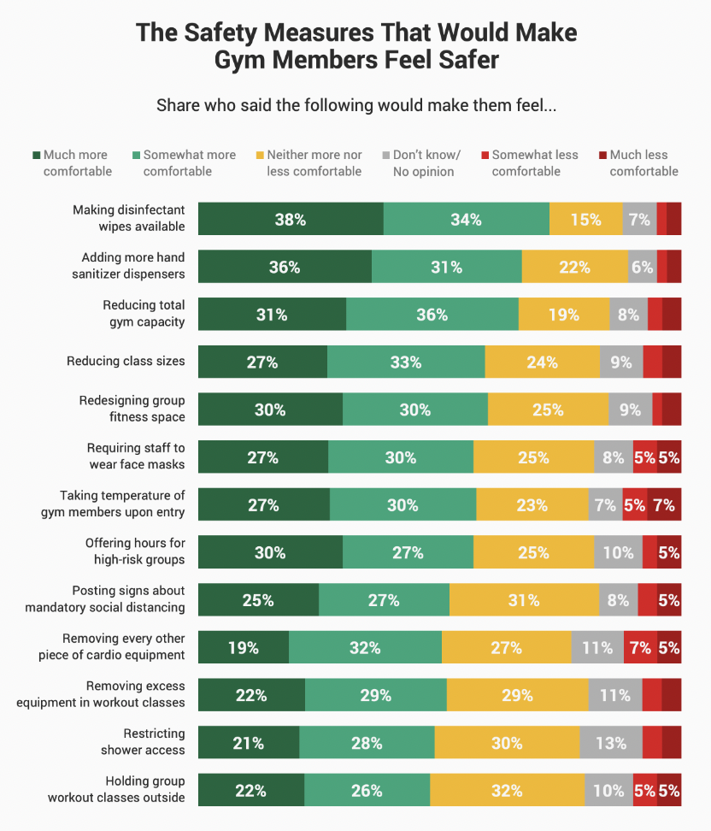

Based on the data collected it can be concluded that gym-goers would feel safe if certain safety measures are implemented by the gym. Specifically, the most popular safety measure is having hand sanitizer or disinfectant wipes available for use, with 88% of respondents saying it would make them feel safe. Other measures that ranked highly include regular cleaning of equipment (86%), enforcing social distancing (85%), requiring staff to wear masks (84%), and requiring members to wear masks (82%).

It is also worth noting that the measures that ranked lowest in terms of making gym-goers feel safe were requiring temperature checks (62%) and limiting the number of people allowed in the gym at one time (69%). This suggests that while some measures are seen as necessary, others may be seen as more intrusive or less effective in ensuring safety. This also shows that a lot of people still are concerned about overall crowding of the gym in relation to sanitization and social distancing. This means our product will be well received by the public.

## Peak Hours & Usage

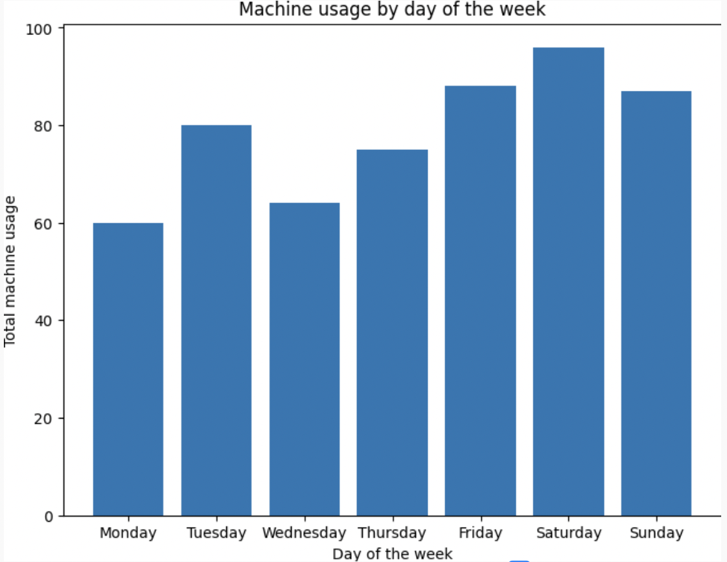

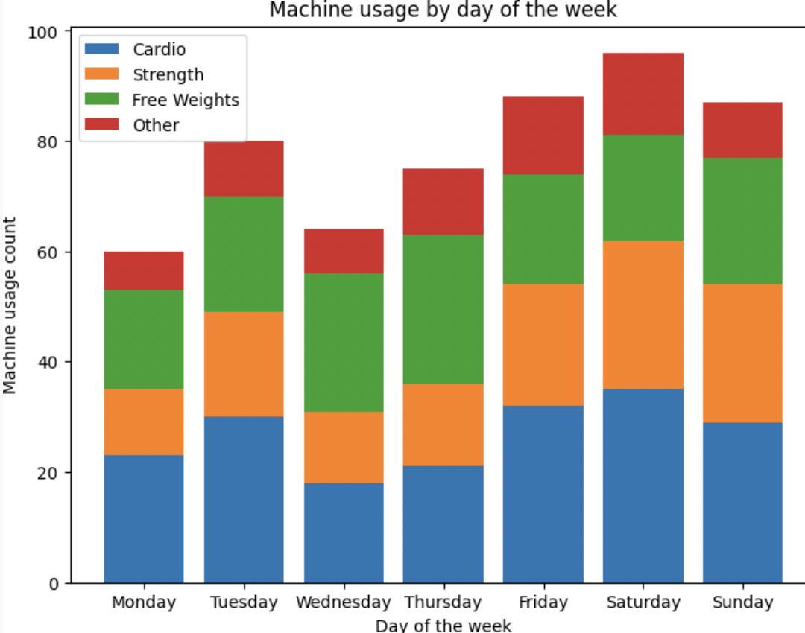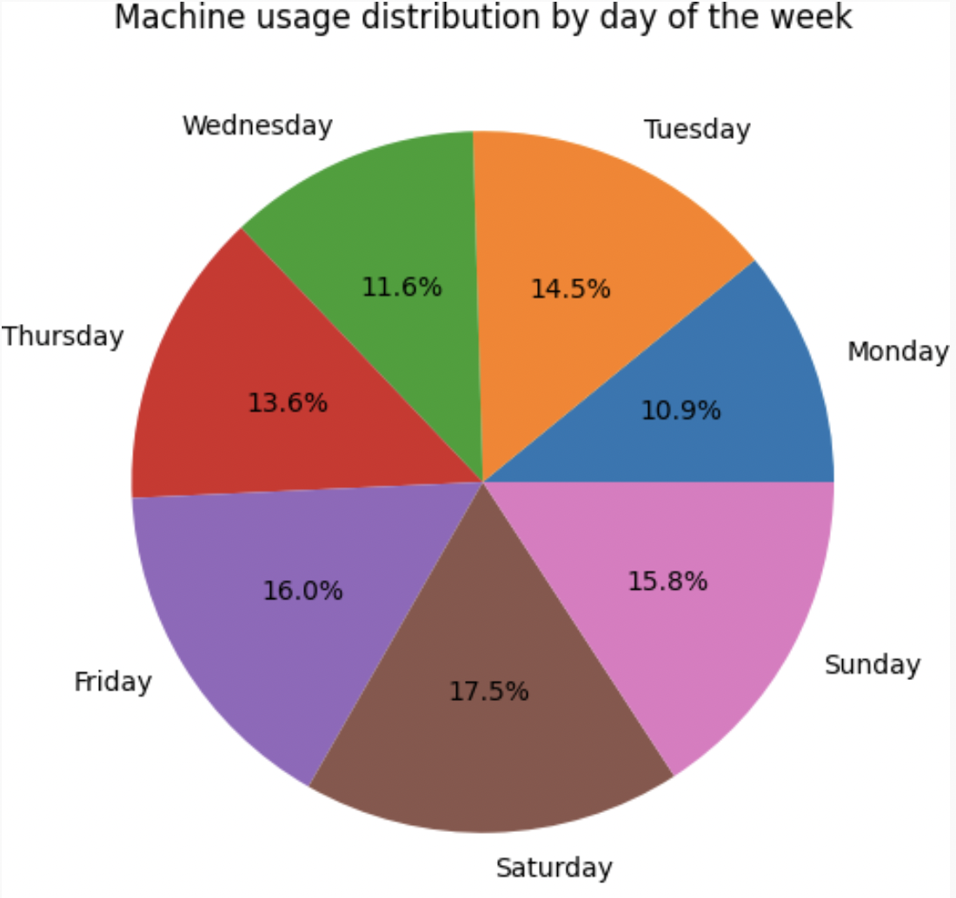

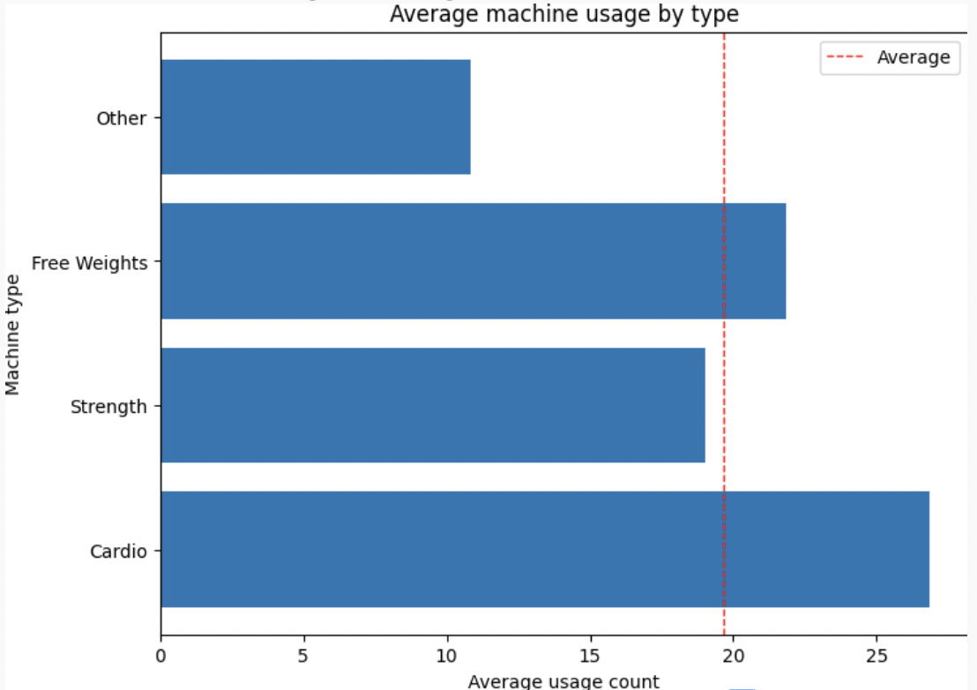

## Data Used

| **Customer ID** | **Gender** | **Age** | **Gym Visits Per Week** | **Average Visit Duration (mins)** | **Most Used Machine** | **Day of Week Most Visited** | **Area of Gym Most Used** |
| --- | --- | --- | --- | --- | --- | --- | --- |
|  | Male | 28 | 4 | 60 | Treadmill | Monday | Cardio Area |
|  | Female | 45 | 2 | 90 | Leg Press | Wednesday | Weightlifting Area |
|  | Male | 33 | 5 | 45 | Elliptical | Tuesday | Cardio Area |
|  | Female | 22 | 3 | 75 | Smith Machine | Thursday | Weightlifting Area |
|  | Male | 50 | 1 | 120 | Stairmaster | Friday | Cardio Area |
|  | Female | 29 | 2 | 60 | Cable Machine | Saturday | Weightlifting Area |
|  | Male | 40 | 4 | 60 | Rowing Machine | Monday | Cardio Area |
|  | Female | 26 | 3 | 90 | Lat Pulldown | Wednesday | Weightlifting Area |
|  | Male | 55 | 2 | 45 | Stationary Bike | Tuesday | Cardio Area |
|  | Female | 33 | 4 | 75 | Leg Extension | Thursday | Weightlifting Area |
|  | Male | 30 | 1 | 120 | Arc Trainer | Friday | Cardio Area |
|  | Female | 27 | 2 | 60 | Cable Crossover | Saturday | Weightlifting Area |

# Primary Market Research Conclusion

Based on these findings, gym owners could consider implementing measures to manage crowding in the gym, such as offering incentives for gym goers to visit during off-peak hours or expanding the gym's space and equipment offerings to provide more options for workout areas. Additionally, gym owners could consider providing more functional training and stretching equipment to encourage gym goers to diversify their workouts and spend less time on the most popular machines.

Below are our conclusions we arrived at based on our data provided:

1. Gym Attendance: The data indicates that most gym goers attend the gym 3-4 times per week, with Monday, Wednesday, and Friday being the most popular days. There is also a significant drop in attendance on weekends, with only a small number of gym goers visiting on Saturdays and Sundays.
2. Workout Duration: The data suggests that gym goers spend an average of 1-2 hours in the gym per session. However, there is a wide range in the length of workouts, with some individuals only staying for 30 minutes while others remain in the gym for 3 hours or more.
3. Popular Machines: The data indicates that cardio machines, such as treadmills and stationary bikes, are the most popular machines in the gym, followed by weightlifting equipment. Gym goers spend the majority of their time on these machines, with little time spent on stretching or functional training equipment.
4. Busy Areas: The data suggests that the most crowded areas of the gym are the cardio machine area and the weightlifting area, particularly during peak hours. There is also a moderate level of crowding in the locker room and shower area.

# Secondary Market Research

The study in the Journal of Sports Behaviour examined demographic, behavioral, and situational predictors of fitness center attendance. Results indicated that age, income, and education level significantly influenced attendance, with younger individuals attending more frequently than older individuals, and those with higher income and education levels attending more frequently than those with lower levels. Additionally, the study found that individuals who perceive themselves as more physically fit were more likely to attend fitness centers. Finally, the study suggests that situational factors such as weather, time of day, and location can also influence attendance patterns.[3]

Aaltonen et al. (2014) found that customer satisfaction with health and fitness clubs is influenced by the quality of facilities, cleanliness, equipment availability, staff competence, and social atmosphere. They also found that members who engage in group exercise classes and receive personalized training are more satisfied with their experience and are more likely to continue their membership.[4]

Prochaska et al. (2008) suggest that behavior change programs should focus on targeting multiple health behaviors rather than individual behaviors alone. They argue that effective interventions should consider the individual's stage of change and offer tailored strategies to address their specific needs.[5]

Nigg and Allegrante (2016) argue that behavior change programs should incorporate behavioral science theories and principles to increase the likelihood of success. They also suggest that interventions should consider the individual's social context and the role of the environment in shaping behavior.[6]

Reaburn and Dascombe (2008) discuss the concept of fitness in athletics and suggest that it involves multiple components such as cardiovascular endurance, muscular strength and power, flexibility, and body composition. They argue that assessments should consider the specific demands of the sport and the individual's goals.[7]

Overall, these sources highlight the importance of considering individual needs, social and environmental factors, and the specific demands of the activity in designing behavior change programs and fitness interventions. According to our research our customers should approve of our innovation with open arms.

# Secondary Research Conclusion

Based on the secondary market research, there are several key insights that can be applied to our Planet Fitness live count tracker project:

1. *Demographic, behavioral, and situational factors* all influence fitness center attendance patterns, so the live count tracker can provide valuable information for gym-goers to decide when to visit the gym.
2. Customer satisfaction with health and fitness clubs is influenced by factors such as the *quality of facilities, cleanliness, equipment availability, staff competence, and social atmosphere*. By providing real-time information on gym capacity, the live count tracker can contribute to a better overall customer experience.
3. Behavior change programs should target multiple health behaviors and consider the individual's stage of *change, specific needs, social context, and environmental factors*. By providing real-time information on gym capacity, the live count tracker can help gym-goers make accurate decisions about their gym attendance and facilitate behavior change towards a more consistent workout routine.
4. Fitness assessments should consider the specific demands of the activity and the individual's goals. By providing real-time information on gym capacity, the live count tracker can help gym-goers plan their workouts around their specific goals and needs, such as avoiding crowded times to focus on strength training or finding optimal times for group exercise classes.

Overall, our research suggests that the Planet Fitness live count tracker project has the potential to meet the needs of gym-goers by providing real-time information on gym capacity that can contribute to a better overall customer experience, facilitate behavior change towards a more consistent workout routine, and help gym-goers plan their workouts around their specific goals and needs.

# SWOT Analysis

**Project specific SWOT Analysis**

Strengths:

* Improving customer experience by providing real-time information about gym occupancy
* Increasing safety for customers by allowing them to avoid overcrowded areas of the gym
* Having a competitive advantage over other gyms that do not offer similar technology
* Potential increase in gym attendance and revenue

Opportunities:

* Potential for future development and integration with other technologies, such as fitness trackers or mobile apps
* Potential for expansion of the technology beyond Planet Fitness locations, such as licensing to other gyms or fitness facilities
* Potential for selling fitness data

Weaknesses:

* Implementation costs could be high, including installation and maintenance of the device
* Possible technical issues with accuracy or compatibility with existing technology
* Concerns about privacy and data security for customers who use the device

Threats:

* Resistance from customers who prefer not to use the device or do not trust the technology
* Competition from other gyms that offer similar or alternative technologies
* Possible legal or regulatory issues related to privacy and data security

## 

## Swot Analysis Conclusion

The strengths of the innovation lie in the benefits it provides to customers, including improved experience and safety, as well as the potential for increased revenue and competitive advantage. The product will save people time, which will definitely attract them to us more. The opportunities for the project include future development and expansion beyond Planet Fitness locations. We can also sell data in the future. These are all open streams of income to the company so we labeled them as opportunities. The implementation costs and technical issues associated with the device represent weaknesses because the cost may be a little pricey, but we need to find out through our primary research whether that price will be worth it or not. Privacy concerns about data security for customers will also be a weakness for the company since we could be taken legal action against. Lastly, our threats consist mainly of user resistance and other Gyms that roll out a similar plan.

## Planet Fitness overall SWOT analysis:

# 

## Project Specific SWOT Analysis:

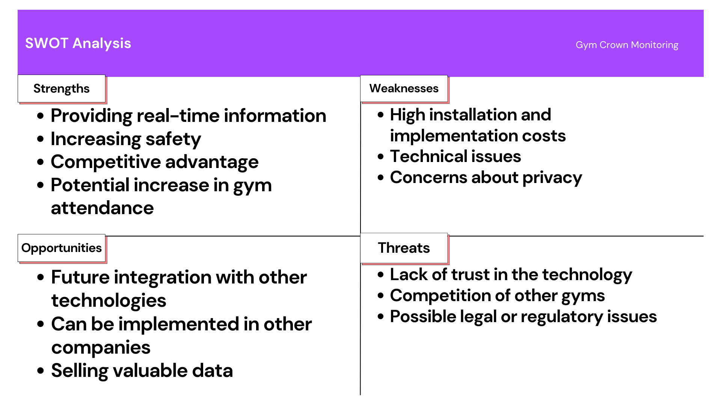

# Magic Quadrant:

**How is our project positioned versus other solutions/products/vendors?**

The project is a unique and innovative solution that addresses the specific needs of fitness enthusiasts during (but not limited to) the COVID-19 pandemic. It offers members the ability to check the number of people currently present in the gym in real-time, allowing them to plan their workouts and avoid crowded spaces. The live count tracker could be positioned as a feature that sets Planet Fitness apart from other gyms and fitness centers that don't offer such a service.

**Why do we place our project on the quadrant where we do?**

We place Planet Fitness in the leaders quadrant because of the following qualities of our live count tracker implementation:

1. Innovation: The project introduces a new and innovative feature that sets it apart from other products in the market.
2. Execution ability: The project team demonstrated strong execution abilities in implementing the feature and ensuring it works smoothly for customers.
3. Market understanding: The project has a deep understanding of the market and customer needs, and the feature has been developed to meet those needs.
4. Customer experience: The feature has been designed with the customer in mind, providing a seamless and easy-to-use experience that enhances the customer's overall satisfaction.
5. Revenue potential: The project may has strong revenue potential, either through increased customer retention and loyalty or potentially through direct sales.

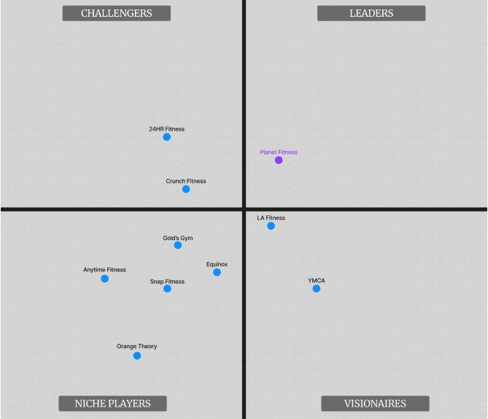

## Niche Players

**Orange Theory**

* Orange Theory is a 1 hour, full body workout, focused on training endurance, strength and/or power. Orange Theory has a main demographic of women more than men, in comparison to other companies they lean towards the older demographic more than all ages. We placed them in the low niche players due to their demographics more than anything else. The company does not take data into consideration when scheduling for classes. meaning there is not a definite number.

**Equinox**

* Equinox Gym is one of the many lifestyle brands of Equinox Group. The group is known as a luxury fitness company, meaning it is very pricey when it comes to memberships. The reason that the company is ranked so low is due to their unfriendliness to beginners which The Product is inclined to the richer people. This gym is not very recommended for beginners due to the price.

**Anytime Fitness**

* Anytime Fitness is a franchise of 24-hour health and fitness clubs that is headquartered in Woodbury, Minnesota, United States. The company operates over 5,000 franchised locations in 50 countries. Although the gym is a good idea in theory, it is said to be known that they have very little to none amenities, which is why its located in the Niche Players section.

**Snap Fitness**

* Snap Fitness gyms offer 24-hour fitness with cardio and strength equipment, personal training, group fitness classes, and a supportive environment. The problem with Snap Fitness is that the company comes under controversy, The company changes their membership fee every so often.

**Gold’s Gym**

* Gold's Gym International, Inc. is an American chain of international co-ed fitness centers originally started by Joe Gold in Venice Beach, California. Each gym offers a variety of cardio and strength training equipment as well as group exercise programs. The problem with Gold’s is there aren't enough of the actual gym locations as much as other gyms.

## Challengers

**Crunch Fitness**

* Crunch Fitness is a U.S.-based brand of over 400 franchised and corporate owned fitness clubs located in the United States, Puerto Rico, Canada, Spain, Portugal, Costa Rica, and Australia. Their main push is to be a commercial olympic gym with free weights and machines. The reason why Crunch Fitness is located in the challengers is because they have yet to keep track of their activities on a regular basis, Not listing when the most active times are. But their amenities are close to what Planet Fitness holds

**24HR Fitness**

* 24 Hour Fitness is a privately owned and operated fitness center chain headquartered in Carlsbad, California. It is the second largest fitness chain in the United States based on revenue after LA Fitness, and the fourth in number of clubs, operating 287 clubs across 11 U.S. states. The reason why 24hr fitness is in the spot it is is due to the fact of their tracking in app. The app is not fully focused on having a finite number and due to their lack of innovation their spot is set at the challenger level.

## Visionaries

**LA Fitness**

* LA Fitness is an American gym chain with more than 700 clubs across the United States and Canada. The reason why LA Fitness is located in the visionaries slot instead of the challengers or niche players is because their idea is very fundamental, there was a plan to incorporate a tracking system but the idea was shut down years ago

**YMCA**

* YMCA gives you access to the gym, as well as basketball courts, swimming pools, jogging tracks, child care, and classes. Although the Y is not a dedicated Gym they have tons of amenities that rival them against some big name gyms on the list. The reason that the company is labeled in the visionaries is due to their idea that everyone can use this gym.

## Magic Quadrant Conclusion

In our Magic Quadrant we focus on the different companies that have ideas to or have tracking implementations. The Competition shows how we can change our product and improve farther beyond what the product idea is now. If this sort of technology is implemented than it could revolutionize the gym industry making it another area to gain data from

# 

# 

# Stakeholders

For project success, it is imperative to engage individuals and groups who have stakes in the project work and outcomes. These individuals or groups are called stakeholders[8]. Our main stakeholder is the company Planet Fitness itself. They are our main project sponsors[9]. Planet Fitness is providing us with the necessary resources to complete our project as well as advocating for our group throughout the course of the project. They are the best stakeholders for our project due to the fact that the company will highly invest in a project that is promising them an increase in profit.

1. Gym owners and managers who will be responsible for purchasing and installing the new device.
2. Gym employees who will be responsible for maintaining and monitoring the device.
3. Gym members who will benefit from the information provided by the device and may be more likely to visit the gym when it is less crowded.
4. Potential new gym members who may be more likely to join the gym if they know they can avoid crowds.
5. Vendors and suppliers who provide the technology and equipment needed for the device.
6. Local health and safety officials who may be interested in the gym's compliance with capacity limits and social distancing guidelines.
7. Investors or shareholders in the gym or its parent company who may be interested in the potential return on investment from implementing the new device.

Stakeholders can also be other people in groups who can have positive or negative influence over the project. For example, we have a group of subject matter experts that specialize in exercise psychology (Internal department at Planet Fitness) that are willing to assist us in researching and understanding the human brian. We plan on using this information to back up our claim of our product enabling beginners to start coming to the gym more often.

When thinking about stakeholders, we should always think about who will be impacted by the project[10]. Our project will impact gym members as well as employees at our fitness centers. Gym members will find it more convenient to check the app before coming to the gym and our employees will stop pulling out their hairs trying to manage a massive crowd during rush hours.

Since we are updating the already existing ‘Crowd Meter’ feature on the app, the employees currently incharge of maintaining the original crowd meter app may pose as resistant stakeholders[11]. This is due to the fact that once we complete our project, those employees working on the older version may be impacted by a job change/excuse notice. Understanding their position may be crucial to our implementation because we need to understand the requirements and help them gain and maintain positive attitudes towards the chance. This will help us to secure much needed support for our project and provide us with a higher chance of acceptance of our results[12].

# Target Audience

This main audience for the project is the new members that would like to get started at the gym but are uncomfortable around a large number of people. The Idea came initially from solving a problem about covid but it can easily be adjusted to change it to the needs of people that are uncomfortable around different types of people; in the gym a lot of people find veterans who work out very intimidating, and in order to help the people that find those people intimidating we can find a time that those types of people are there the least. On the other hand, veterans can also use the application to identify which machines are available and how much time they can afford to spend on a single machine while waiting on the next one.

## Potential Audience

Additionally, this product can also assist gyms that are suffering from overcrowding at certain times and lack of crowding at other times. Users can see when the peak hours are listed, and also double check whether the given peak hours are accurate for the day or not. This idea would be beneficial to our gym locations across the country because less concentrated traffic in a nice gym is much more enjoyable. This will enhance user experience which will make them want to keep coming back to the same gym location, and not competitors instead. To add on, other companies could be interested in our immense amount of data for research purposes. In order to make members have a better experience, we will build up a large amount of data which will help us identify key aspects in our gyms that need changes. For example if a large amount of people are located around a designated location for a certain type of machine it could be said that either the machines need to be moved into a more open space or to get more of the machine to reduce foot traffic. We can use this data and make it an additional stream of revenue for the company.

# Scope

#### In-Scope

The Scope of this project is very local to us, we decided to narrow our locations from all of New Jersey to a select amount of locations. The locations range from the different counties in New Jersey, those counties being Essex County, Middlesex County, and Camden County. We Initially plan to roll out the project in several locations so that we get a finite amount of data that can represent the areas that are chosen. As well as the gathered data from each location we can convert it to information, and then proceed with improvements for implementing the idea in different locations. Our main goal is to provide users with a live count of the facility. In order to achieve this goal, we will be using the already existing Planet Fitness application (Crowd Meter) to be the interactable portion of the project. The users can directly go onto the app and view the details from there. Additionally, we will require motion sensors as well as motion cameras in order to keep track of the crowd. Another aspect that we are trying to incorporate into the product is a tracking system that can determine which machines are being used over the days.

We will try to implement the idea on the IOS platform first and then incorporate a UX design to incorporate for the Android platform.

#### Out of Scope

Planet Fitness has over 2400 locations, and we cannot reach all of them for this project. So we will be limiting to a certain number of clubs that are in-scope within predetermined geographical boundaries.

Additionally, any data stored using the devices can be used for other data science purposes, which our team will not directly handle, but could easily be implemented as per Planet Fitness requirement.

Upon completion of the project and monitoring feedback, the technology we created could be patented and sold to other private gyms as an additional stream of income.

# Ethics, Privacy, and Security Issues

When developing the live count tracker project for Planet Fitness, ethical, security, and privacy issues must be considered to ensure that the project is developed responsibly.

## What are they and how will we solve them?

Some ethical issues that need to be addressed include the potential for inappropriate use of data collected by the live count tracker system, such as profiling or discrimination against certain groups of gym members based on their demographic data. Additionally, the live count tracker system may infringe on the privacy of gym members by collecting personal data without their consent. This is a common issue in many applications that users use today, and it is becoming an even bigger issue with applications that track your location. Location tracking can be vulnerable to many crimes related to stalking and gaining access to people that are in fact trying to stay under the radar. To address these ethical issues, clear policies and guidelines will be implemented for the use of data collected by the system. Additionally, we will require regular ethics training for all employees involved in the project to ensure they understand the importance of ethical data practices. The vendors will also be held responsible for any data leaks that happen on their servers/system.

Security is another important consideration for the project. There is a risk of unauthorized access to the live count tracker system by malicious actors who may steal or misuse sensitive data. Additionally, there is the possibility of cyber-attacks targeting the live count tracker system, which may result in the compromise of gym member data. To address these security issues, strong access controls should be implemented to limit access to the live count tracker system to authorized personnel only. Additionally, regular vulnerability assessments and penetration testing should be conducted to identify and address any potential security risks. Planet fitness is already a large company that interacts with gym goers on a daily basis, which means they already have teams and standards set in place in order to counter any malicious actors.

Privacy is also an important issue that must be considered. There is a risk of gym members' personal data being shared or sold to third-party entities without their consent. The live count tracker system must comply with data protection laws and regulations, such as GDPR (General Data Protection Regulation), CCPA (California Consumer Privacy Act), and HIPAA (Health Insurance Portability and Accountability Act). To address these privacy issues, clear privacy policies should be implemented that outline how the data collected by the live count tracker system will be used and shared. Anonymization techniques should also be used to remove personally identifiable information from the data collected by the live count tracker system to protect gym members' privacy.

## Managing Costs

The costs associated with managing these issues and implementing the proposed solutions will depend on various factors. Some of the costs that may need to be considered include personnel costs for training employees and implementing security and privacy measures, technology costs for implementing access controls, anonymization techniques, and legal costs for ensuring compliance with data protection laws and regulations. If the company were to fall into any legal trouble because of our project, we would be forced to surpass our budget, which would probably end up causing the project to be shut down or reassigned by the Planet Fitness Managers.

In summary, ethical, security, and privacy issues must be considered when developing the live count tracker for Planet Fitness. Addressing these issues involves implementing various measures to ensure the ethical use of data, the security of the live count tracker system, and the privacy of gym members. The costs associated with managing these issues and implementing proposed solutions will not directly affect our project since Planet Fitness already has standards in place for security/privacy of data on their application. However, we would need to train out team members and vendors to make sure everyone is aware of faulty practices while working on the project.

# Financials

## Financial Spending + Investment

The financials were slightly adjusted from Stage 3’s financials. The main differences are the price and cost escalation percentages. Those start to increase right around the time where we break even and then go up, since we most likely will be investing more money into the product as it expands and becomes more popular. These higher percentages contribute to the increase of the Internal Rate of Return.

The initial investment will be slightly higher ($7,75) since project launch is going to include prototypes and initial implementation. After the first year, we are looking at a constant investment of about 500 to eventually not at all once the project is stable

## Monthly

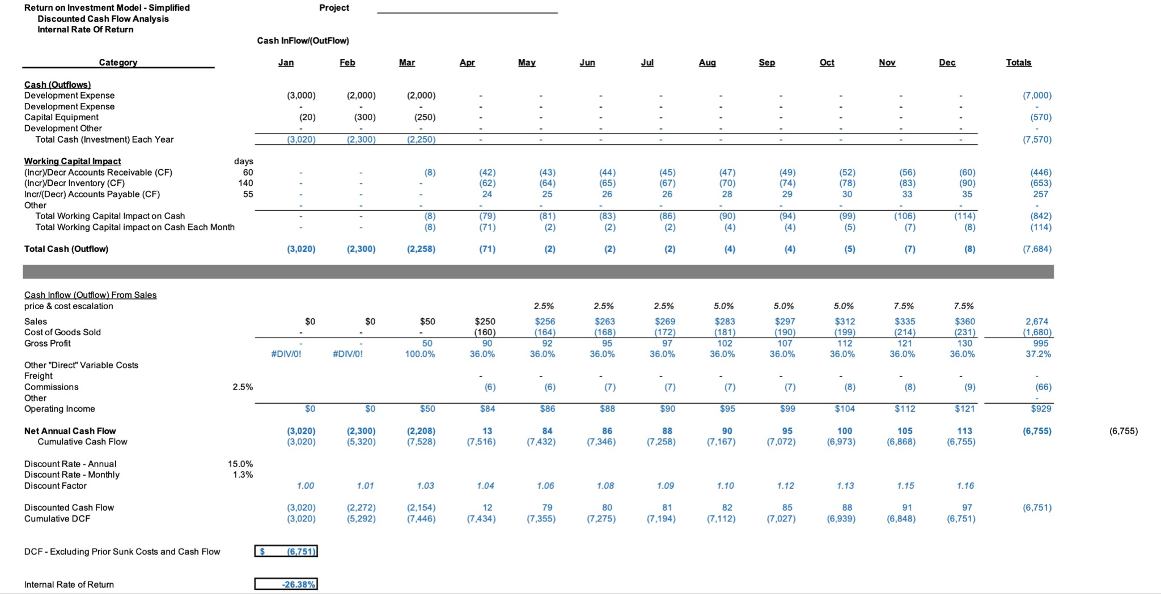

**Investment:**

1. Hardware: Our investment will depend on the type and number of sensors we need for your project, as well as the other hardware components such as microcontrollers, displays, and batteries.
2. Software: Our investment will also depend on the software development costs, including the programming languages, tools, and frameworks used for your project, as well as the cost of any third-party services or APIs you may need.
3. Design: The cost of designing the sensor's physical appearance and packaging, including any graphic or UX/UI design, can affect your investment.
4. Manufacturing: The cost of manufacturing and assembling the sensors, including the production

## 10 Year Annual

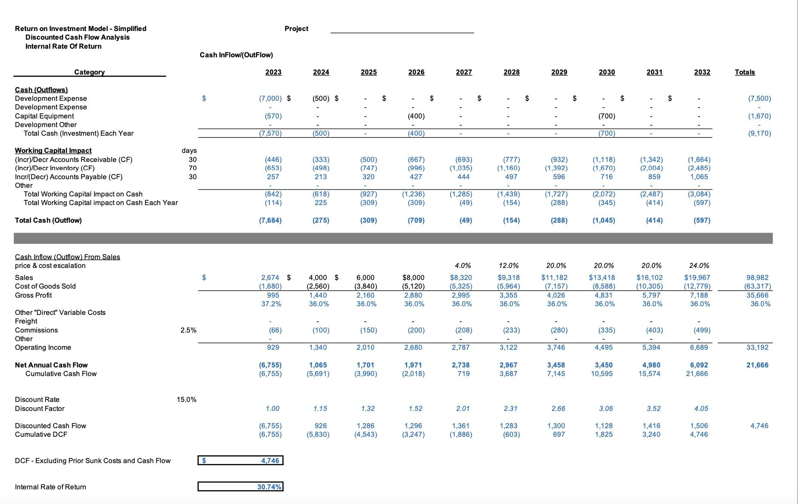

## Cash Flow

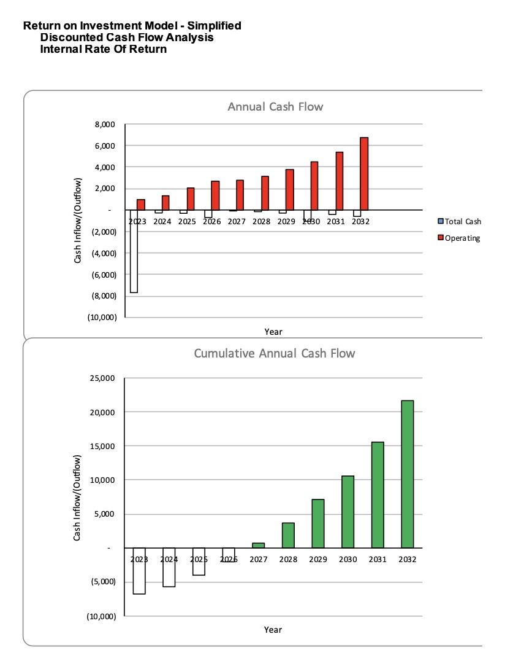

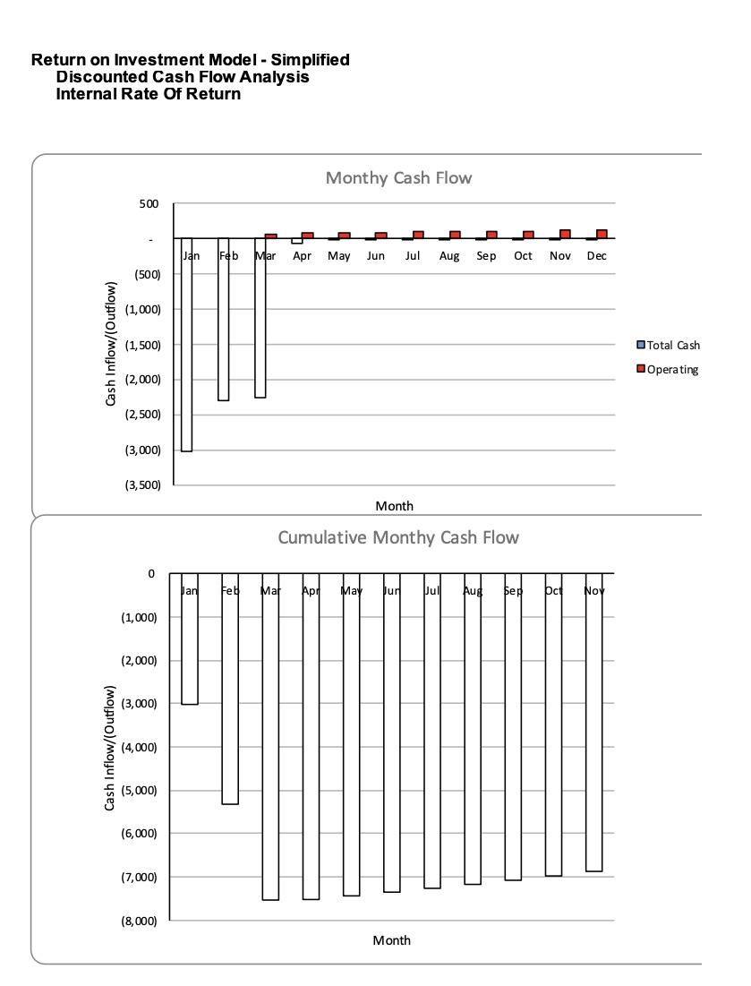

# Draft UI/UX

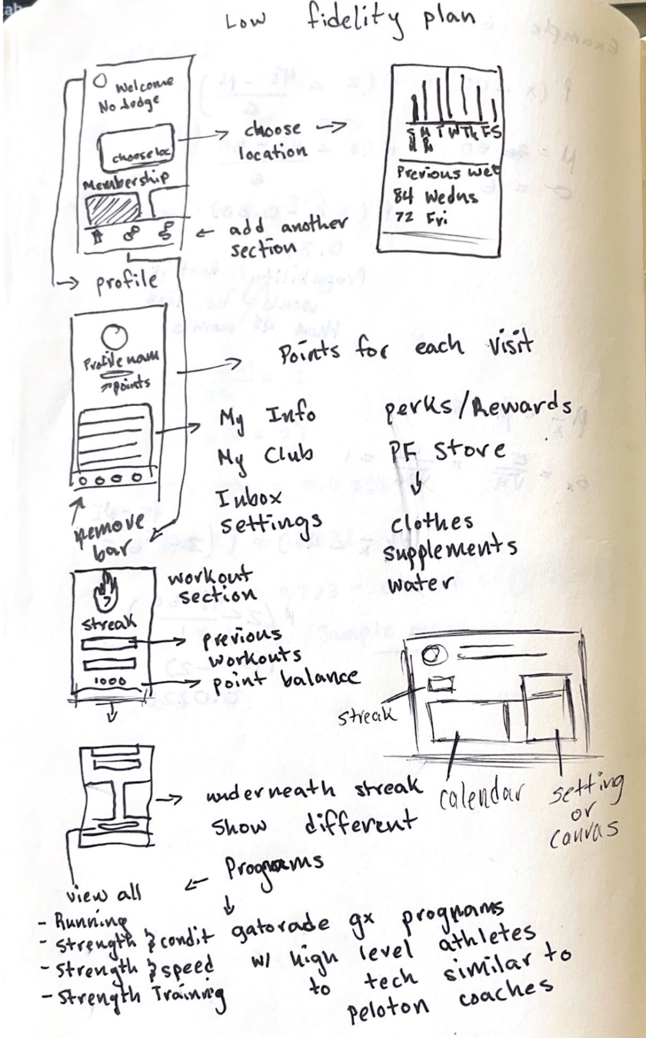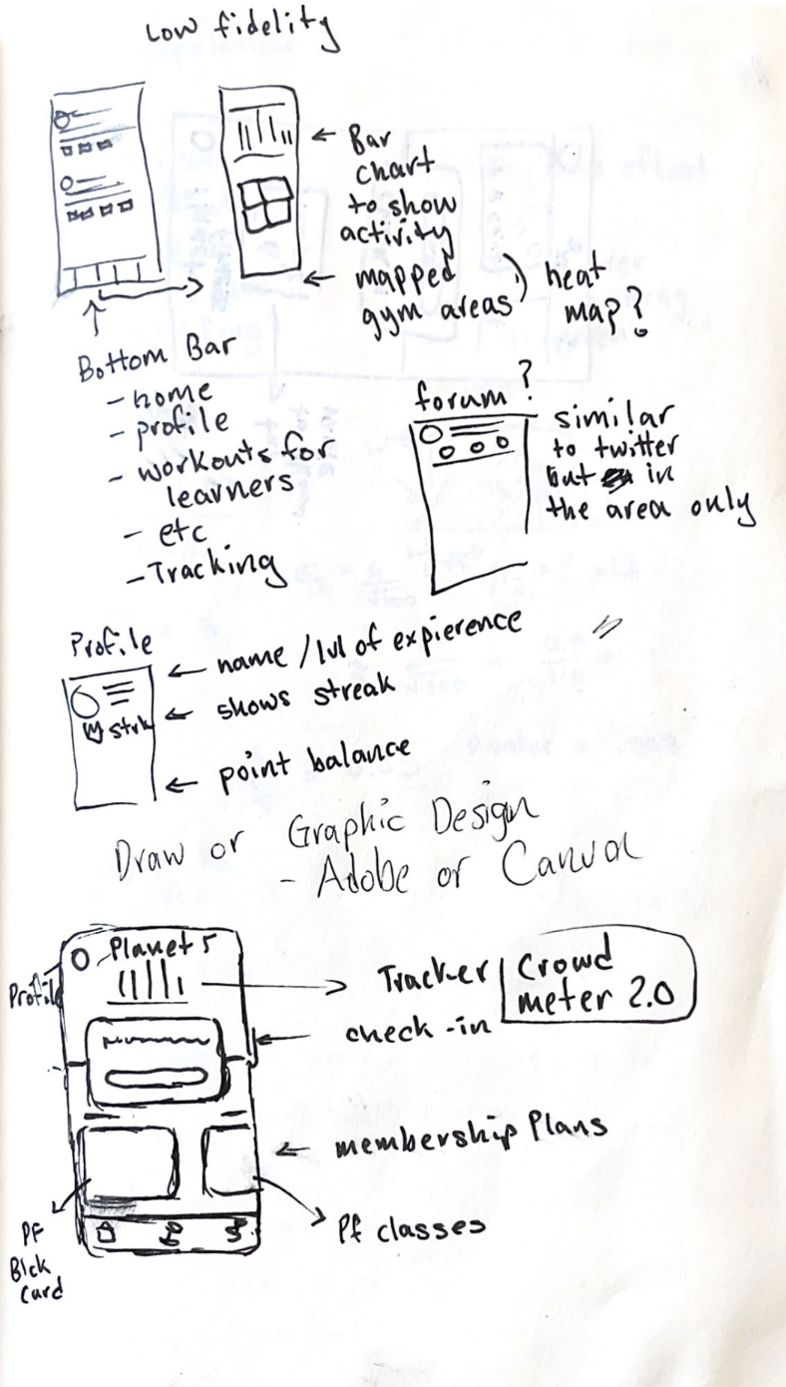

# High Fidelity

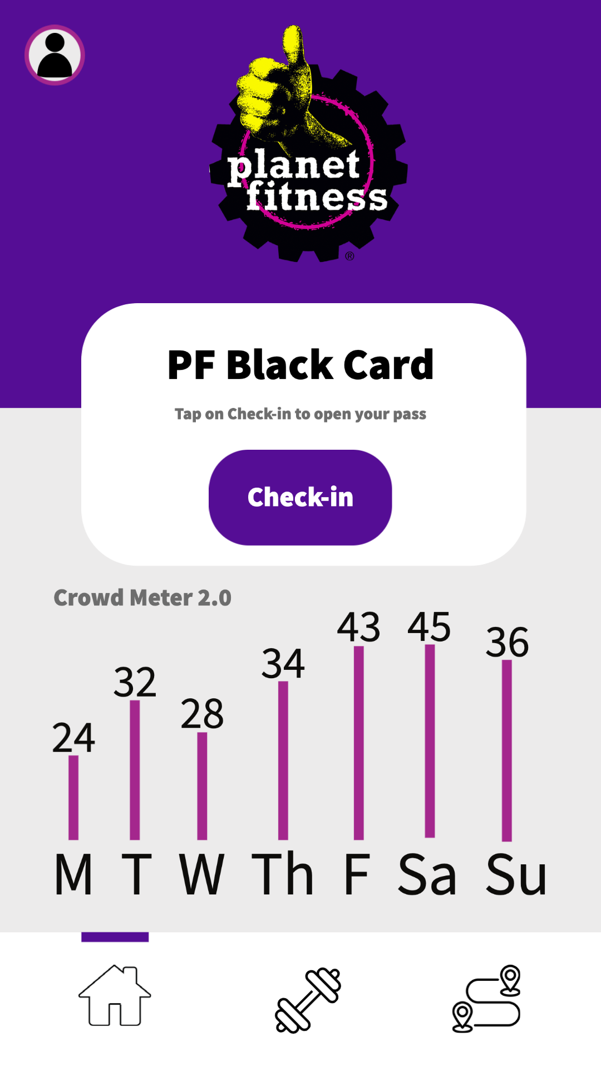

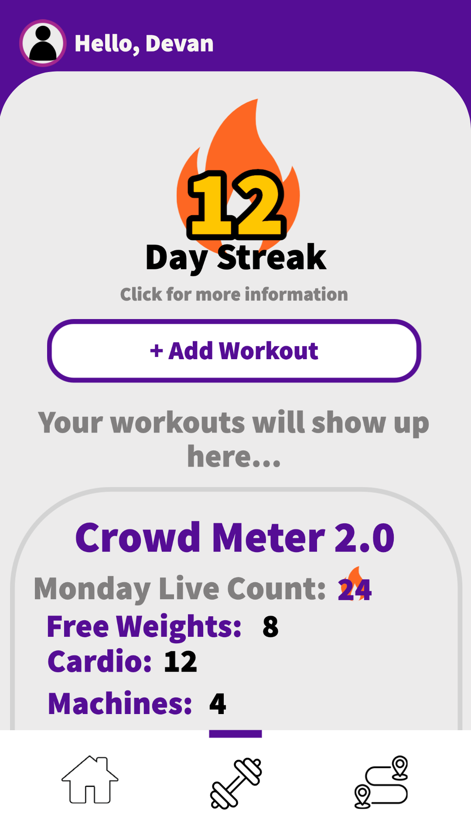

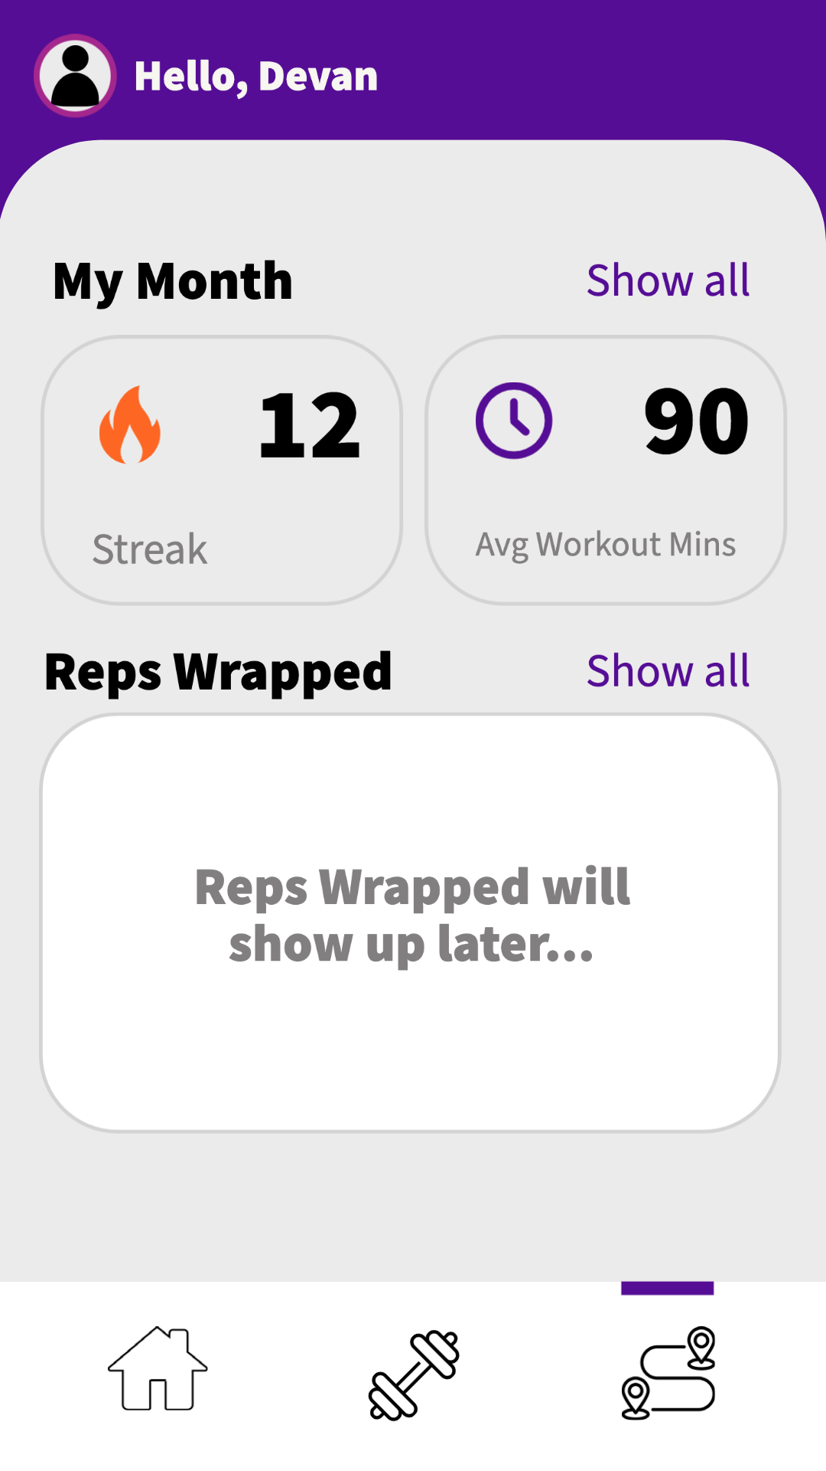

# High Fidelity Hardware:

The counter will be updated depending on which laser is broken first. Incoming and outgoing traffic can simply be tracked by keeping track of the order the lasers have been set up in and which laser is disconnected before the next laser.

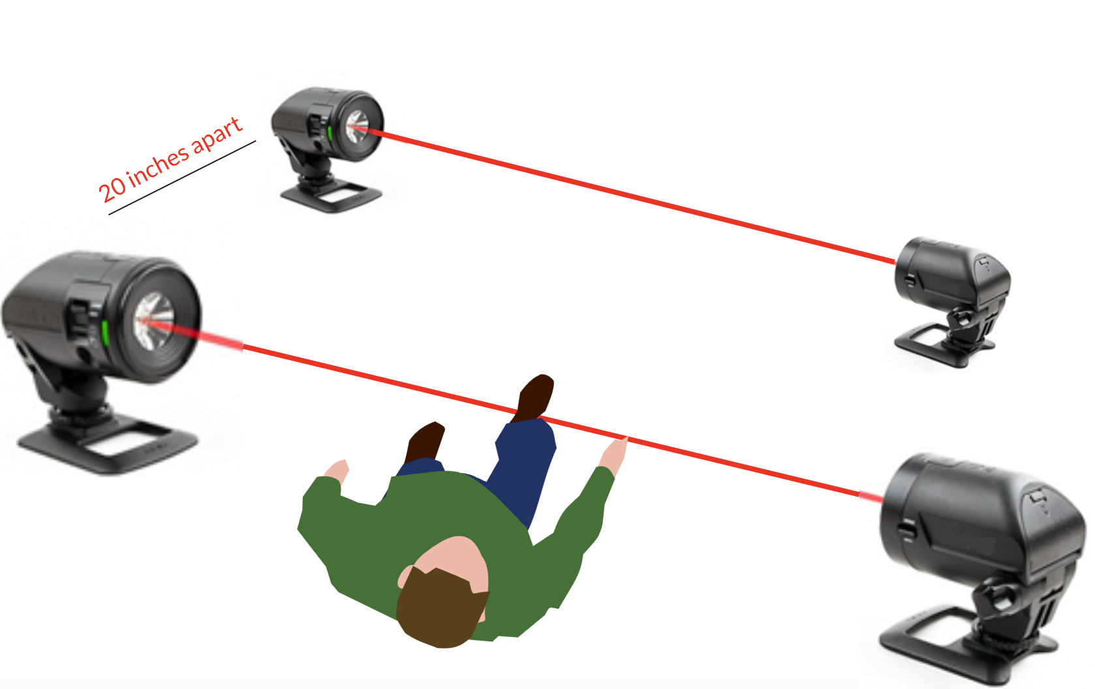

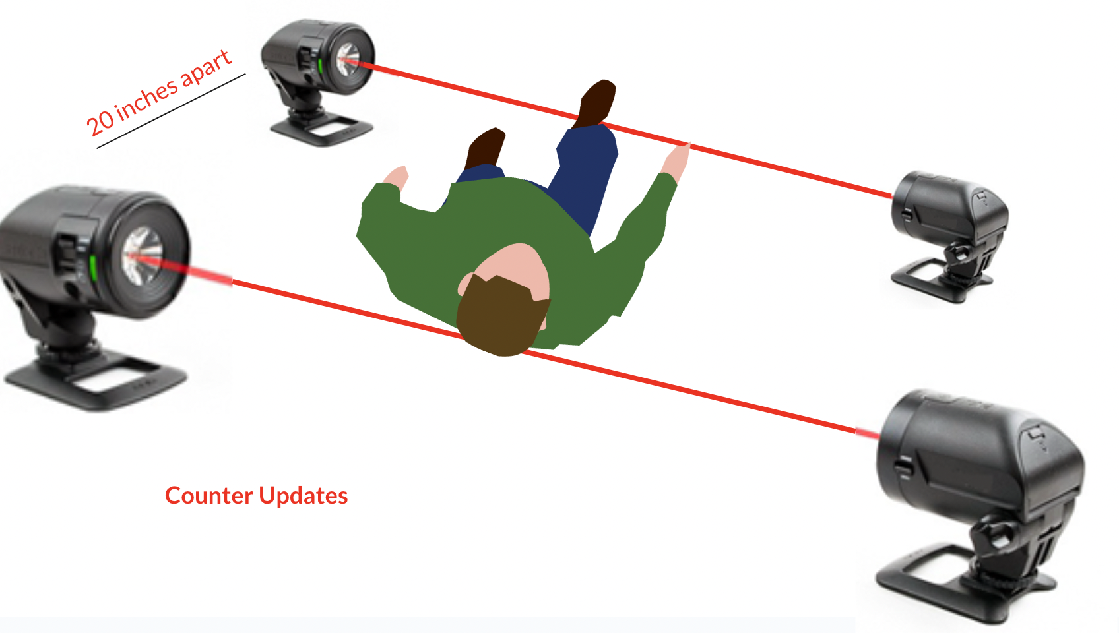

# Gantt Chart

# 

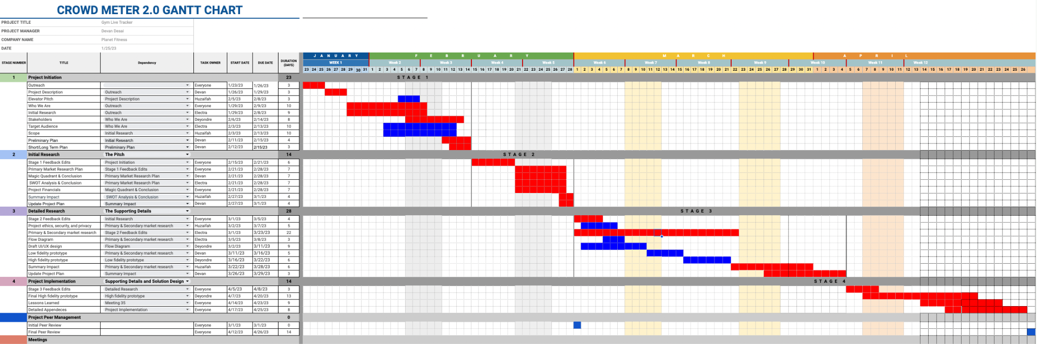

# Work Break Down

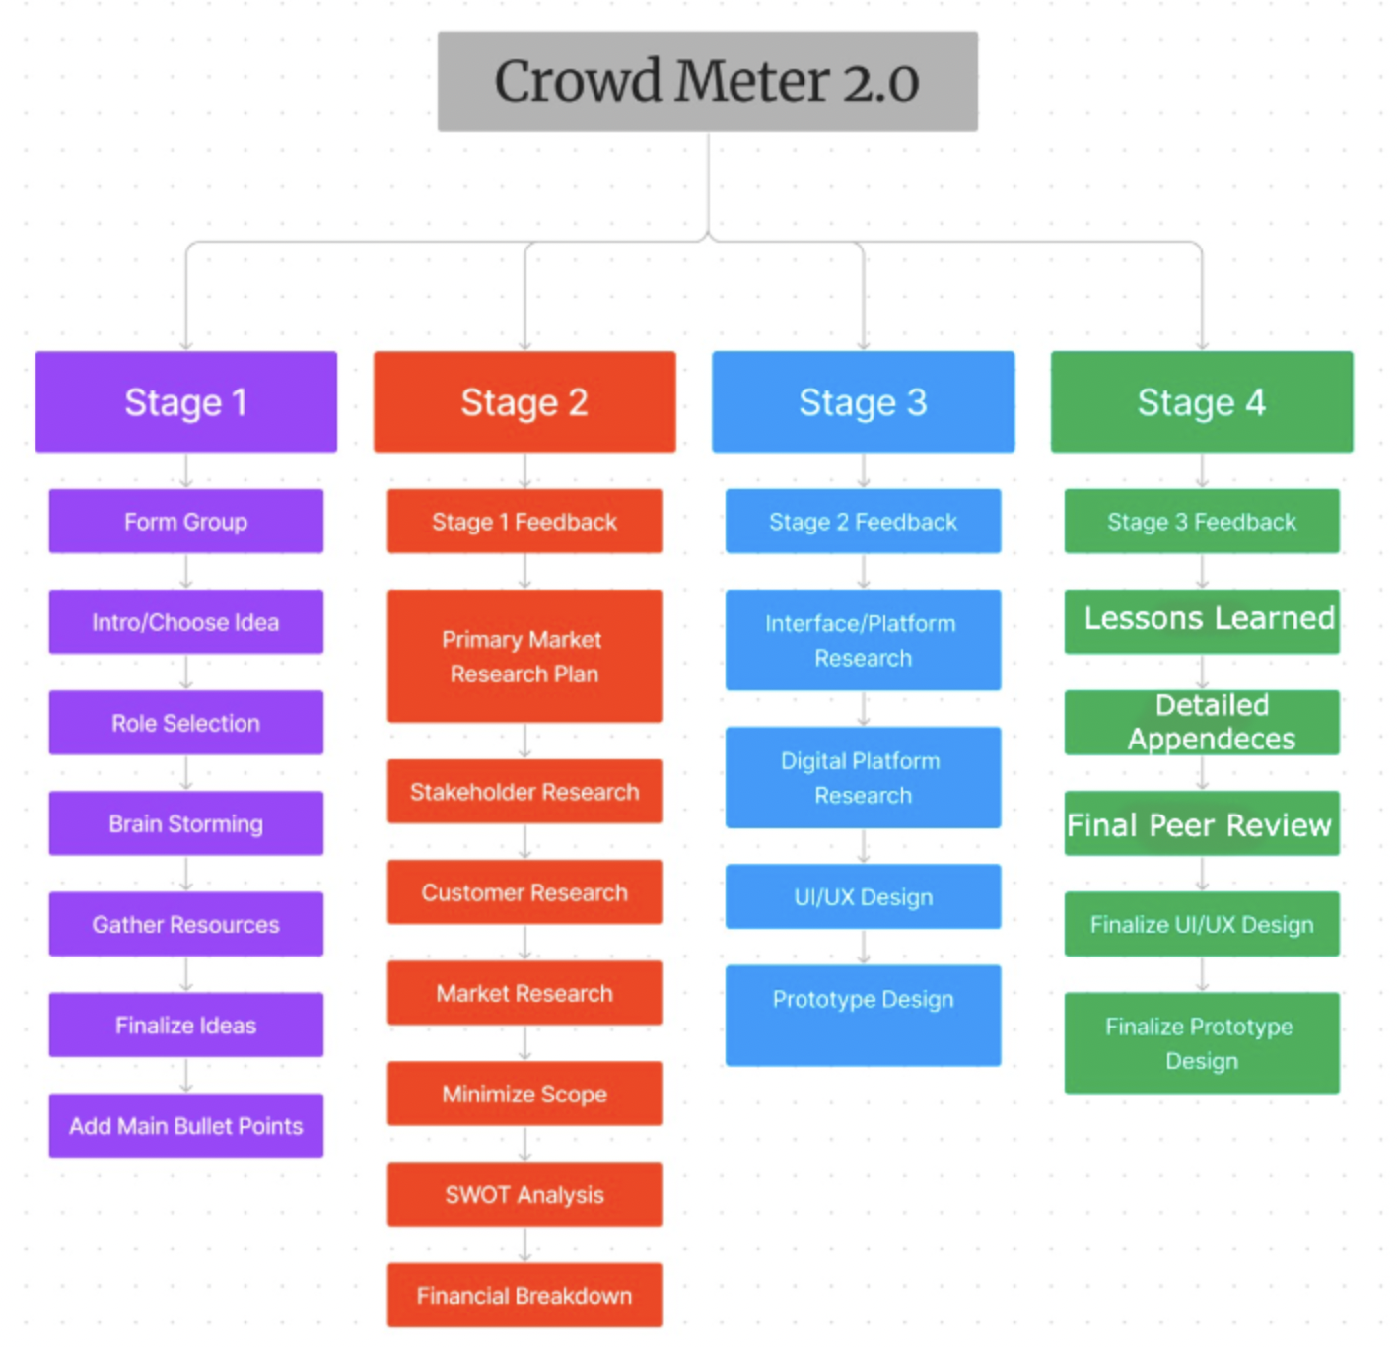

#### 

# Cross Functional Diagram

# Context Plan

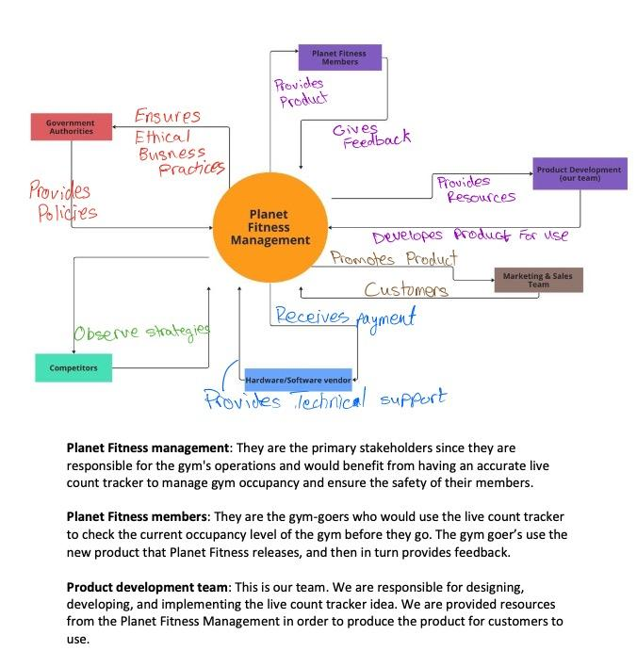

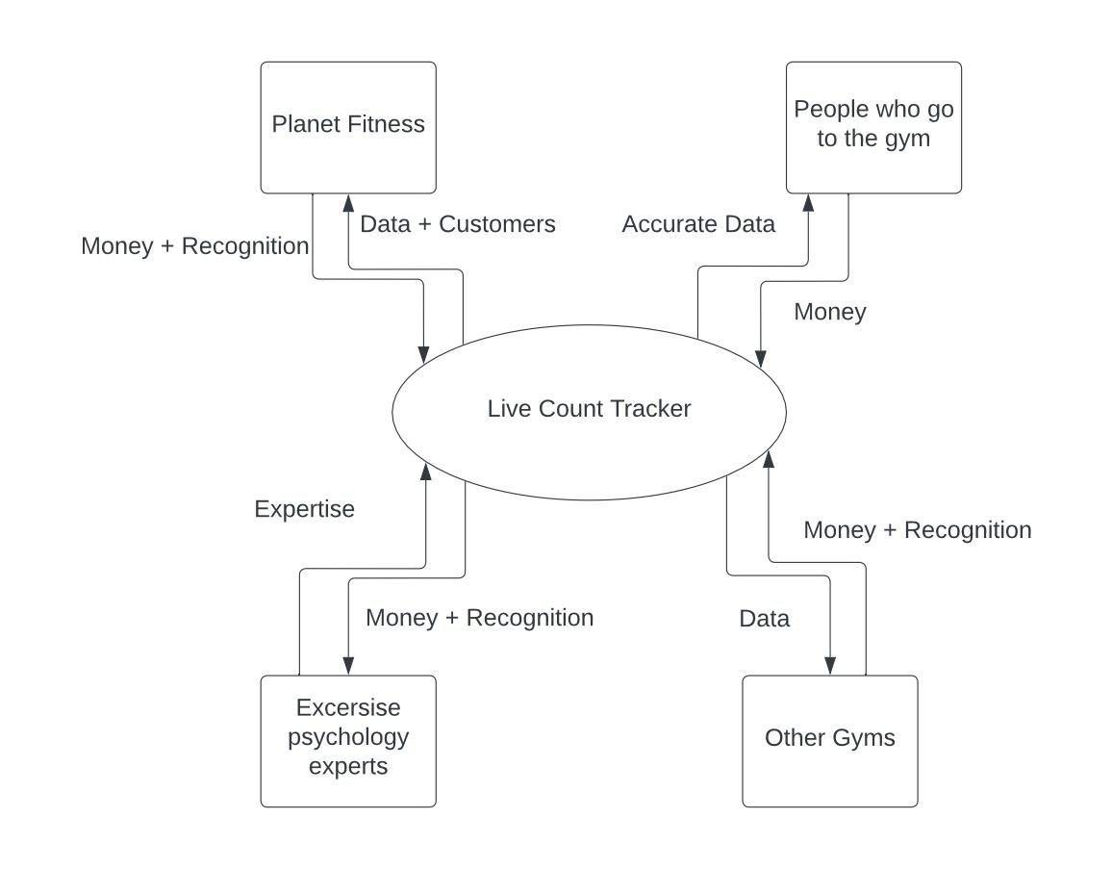

## Context Plan Explanation

**Planet Fitness management:** They are the primary stakeholders since they are responsible for the gym's operations and would benefit from having an accurate live count tracker to manage gym occupancy and ensure the safety of their members.

**Planet Fitness members:** They are the gym-goers who would use the live count tracker to check the current occupancy level of the gym before they go. The gym goer’s use the new product that Planet Fitness releases, and then in turn provides feedback.

**Product development team:** This is our team. We are responsible for designing, developing, and implementing the live count tracker idea. We are provided resources from Planet Fitness Management in order to produce the product for customers to use.

**Marketing and sales team:** They are responsible for promoting the product once we develop it and it is released and in return, planet fitness gets more customers.

**Hardware and software vendors:** They are the suppliers of the sensors and other technology needed to develop and implement the live count tracker. In addition to helping us create the foundations of the application, the vendor will also provide technical support while Planet Fitness pays them.

**Government authorities:** Government authorities such as health inspectors and data regulation services may have an interest in ensuring that the gym is complying with occupancy limits sand data safety regulations. Data safety regulations are an upcoming subject matter since a lot of governments have started stepping in and making companies accountable for any sensitive breaches. To prevent this, we will be using government policies in order to stay out of legal trouble.

This context diagram shows the main external entities of our product. Additionally, this diagram can help us identify the key external entities that interact with our product and the relationships between them. It can also help us define the scope of our product and the boundaries between the internal and external components of the system. If we had done this exercise earlier, our group would have been able to fix our scope early on in the stages. Overall, a very helpful diagram for initial planning as well.

# Summary of Impact

## Stage 2

* Updating our Gantt chart to include all 4 states has helped us stay more organized and see the bigger picture in the project plan.
* Adjusted our scope so that we limited the gyms we would implement our device in. This will help us in getting better/ more accurate information which we can later process as primary research.

## Stage 3

* Updated Gantt chart to include dependencies
* Added market supporting detail, which helped us to have better design for our low fidelity prototype
* Added Swot Analysis Conclusion
* Added Magic Quadrant and Conclusion
* Adjusted IRR % which led to quicker break even

## Stage 4

* Decreasing Working Capital days caused a decrease in Total Cash Outflow which positively impacted our Internal Rate of Return to 30.75%!
* Added Financial Spending + Initial Investment details for insight

# Lessons Learned

## Team Dynamics

* Member leaving the project halfway through gave us a challenge but we were able to overcome it by redistributing the workload
* Some roles needed to be re-assigned as well
* Picking up work of other members came into play when it came closer to deadlines

## Teamwork vs. Individual work

* Self pacing
* Meeting deadlines
* Tracking changes that other team members had done so project progress was not impacted

## Effective Communication

* Reaching out to everyone
* Setting meeting times
* Assigning roles

## Planning and Organization

* Using Gantt chart to stay organized
* Using Gantt chart to set meeting times
* Different platforms to communicate
* Shared folders and documents

# Appendices

1 Croft, C. (2020, March 18). *Project Management Simplified*. Linkedin Learning. Retrieved February 14, 2023, from <https://www.linkedin.com/learning/lti?lis_result_sourcedid=AQHoAv9aRNqKEgAAAYZSCGrvQvuR09Nl8kUIIoGFuAxQ92Z1uaKf28oJBr9IhcSgtRlWFwrMEOZB_vv80g9cXcEqg7-YZqiN923_JfCuUIfHIgZ9b5ZcUUmjQ_z8XhfUuTiJW0s&lis_outcome_service_url=AQHkFoaW65ORPgAAAYZSCGrvJsjswNBXCaJoCf5313lLd4ww0XNvx894CilpeCMrByJuF1R-6UG8Qt_nm0Rljt-zQ8Eo8eWqgq2JoHyJkOA_wbdWoWGxiLSRrRExmrqga1rjGigJ&roles=AQFW61dSlfS5tgAAAYZSCGrvOJSg4uFdg0DzgA36Q8iHQ8DHWlih1D4>

2 Croft, C. (2020, March 18). *Project Management Simplified*. Linkedin Learning. Retrieved February 14, 2023, from <https://www.linkedin.com/learning/lti?lis_result_sourcedid=AQHoAv9aRNqKEgAAAYZSCGrvQvuR09Nl8kUIIoGFuAxQ92Z1uaKf28oJBr9IhcSgtRlWFwrMEOZB_vv80g9cXcEqg7-YZqiN923_JfCuUIfHIgZ9b5ZcUUmjQ_z8XhfUuTiJW0s&lis_outcome_service_url=AQHkFoaW65ORPgAAAYZSCGrvJsjswNBXCaJoCf5313lLd4ww0XNvx894CilpeCMrByJuF1R-6UG8Qt_nm0Rljt-zQ8Eo8eWqgq2JoHyJkOA_wbdWoWGxiLSRrRExmrqga1rjGigJ&roles=AQFW61dSlfS5tgAAAYZSCGrvOJSg4uFdg0DzgA36Q8iHQ8DHWlih1D4><iRedirect=https%3A%2F%2Fwww%2Elinkedin%2Ecom%2Flearning%2Fproject-management-simplified-2019%3Fu%3D76115650&clientKey=AQEq2_SmSFQa-QAAAYZSCGrvIls67xTXXqGQZjrykvrPnKmQieSukvWkmhW0U0qEpHY

3 Kasimtseva, N. (2019, October 8). *Why stakeholders matter - managing project stakeholders video tutorial: Linkedin learning, formerly Lynda.com*. LinkedIn. Retrieved February 14, 2023, from <https://www.linkedin.com/learning/managing-project-stakeholders-2/why-stakeholders-matter?autoplay=true&contextUrn=urn%3Ali%3AlyndaLearningPath%3A1~AAAAAASJbsI%3D567265&leis=LTI&standalone=true&u=76115650>

4 Kasimtseva, N. (2019, October 8). *Why stakeholders matter - managing project stakeholders video tutorial: Linkedin learning, formerly Lynda.com*. LinkedIn. Retrieved February 14, 2023, from <https://www.linkedin.com/learning/managing-project-stakeholders-2/why-stakeholders-matter?autoplay=true&contextUrn=urn%3Ali%3AlyndaLearningPath%3A1~AAAAAASJbsI%3D567265&leis=LTI&standalone=true&u=76115650>

5 Kasimtseva, N. (2019, October 8). *Why stakeholders matter - managing project stakeholders video tutorial: Linkedin learning, formerly Lynda.com*. LinkedIn. Retrieved February 14, 2023, from <https://www.linkedin.com/learning/managing-project-stakeholders-2/why-stakeholders-matter?autoplay=true&contextUrn=urn%3Ali%3AlyndaLearningPath%3A1~AAAAAASJbsI%3D567265&leis=LTI&standalone=true&u=76115650>

6 Murphy, R. M., & Murphy, K. M. (2018). *Manager vs. leader: Untying the gordian knot*. Routledge/Taylor & Francis Group.

7 Herrity, J. (2019, October 7). *5 roles and responsibilities of a team leader | indeed.com*. Indeed Career Guide. Retrieved February 14, 2023, from <https://www.indeed.com/career-advice/career-development/responsibilities-of-a-team-leader>

Thomas, J. J., Nelson, J. K., & Silverman, S. J. (2018). An Examination of Demographic, Behavioral, and Situational Predictors of Fitness Center Attendance. Journal of Sport Behavior, 41(3), 298-313.

Aaltonen, S., Leskinen, T., Heinonen, O. J., Kujala, U. M., & Kaprio, J. (2014). Health and fitness clubs–Determinants of attendance and customer satisfaction. Journal of Sports Science & Medicine, 13(4), 767-774.

Prochaska, J. J., Spring, B., & Nigg, C. R. (2008). Multiple health behavior change research: An introduction and overview. Preventive Medicine, 46(3), 181-188.

Nigg, C. R., & Allegrante, J. P. (2016). Reflections from the Intersection of Behavioral Science and the Fitness Industry. Journal of Behavioral Medicine, 39(1), 1-6.

Reaburn, P., & Dascombe, B. (2008). How do we know if athletes are fit? The concept of fitness in athletics. Journal of Science and Medicine in Sport, 11(5), 428-438.

Buman, M. P., Winter, S. J., Sheats, J. L., Hekler, E. B., Otten, J. J., Grieco, L. A., ... & King, A. C. (2016). The Active-At-Work pilot study: a worksite intervention to increase physical activity. American Journal of Preventive Medicine, 50(2), e71-e81.

Carlson, J. A., Sallis, J. F., Conway, T. L., Saelens, B. E., Frank, L. D., Kerr, J., ... & Cain, K. L. (2012). Interactions between psychosocial and built environment factors in explaining older adults' physical activity. Preventive Medicine, 54(1), 68-73.

Dubbert, P. M., Cooper, K. M., Kirchner, K. A., Meydrech, E. F., Bilbrew, D., & Franks, R. D. (2018). Effects of nurse counseling on walking for exercise in elderly primary care patients. The Journals of Gerontology: Series A, 53(5), M314-M319.

Finkelstein, E. A., Trogdon, J. G., Cohen, J. W., & Dietz, W. (2009). Annual medical spending attributable to obesity: payer-and service-specific estimates. Health Affairs, 28(5), w822-w831.

Pescatello, L. S., MacDonald, H. V., Ash, G. I., Lamberti, L., Farquhar, W. B., Arena, R., ... & Johnson, B. T. (2015). Assessing the existing professional exercise recommendations for hypertension: a review and recommendations for future research priorities. Mayo Clinic Proceedings, 90(6), 801-812.from<https://www.crunchbase.com/organization/aura-health/company_financials>

Nav. (n.d.). Startup Costs: How Much Money Will You Need? Retrieved February 14, 2023, from<https://www.nav.com/business-formation/startup-costs/>

Nav. (n.d.). The Costs of Starting a Business: A Guide to Understanding Startup Costs. Retrieved February 14, 2023, from<https://www.nav.com/business-formation/startup-costs/>

Nav. (n.d.). What are Common Business Startup Costs? Retrieved February 14, 2023, from<https://www.nav.com/business-formation/startup-costs/>

Elite Daily. (2018, February 7). How Working Out Makes You More Confident From The Inside Out, According To Science. Retrieved from<https://www.elitedaily.com/p/how-working-out-makes-you-more-confident-from-the-inside-out-according-to-science-8565734>

Geocaching. (n.d.). Geocaching Trackable Items. Retrieved from<https://www.geocaching.com/track/>

Impinj. (n.d.). Topgolf Transforms Golf Driving Ranges with RAIN RFID. Retrieved from<https://www.impinj.com/library/customer-stories/topgolf-transforms-golf-driving-ranges-with-r>

Curves. (2021, February 8). 7 Ways Exercise Improves Self-Esteem. Retrieved from<https://www.curves.com/blog/belong/7-ways-exercise-improves-self-esteem>

Wikipedia. (2022, March 2). Indoor Positioning System. Retrieved from<https://en.wikipedia.org/wiki/Indoor_positioning_system>

Bote, J. (2019, March 19). Americans Aren't Lazy — We're Just Scared Of The Gym. New York Post. Retrieved from<https://nypost.com/2019/03/19/americans-arent-lazy-were-just-scared-of-the-gym/>

Study Finds. (2019, June 24). Study: Half Of Americans Afraid Of Working Out. Retrieved from<https://studyfinds.org/gymtimidation-half-americans-afraid-working-out/>

Myprotein. (2019, June 24). Which States Are Most Impacted By Gymtimidation? Retrieved from<https://us.myprotein.com/thezone/motivation/which-states-are-most-impacted-by-gymtimidation/>

Polar. (2019, June 26). How to Overcome Gym Anxiety. Retrieved from<https://www.polar.com/blog/gym-anxiety/>

1. Murphy, R. M., &amp; Murphy, K. M. (2018). Manager vs. leader: Untying the gordian knot. Routledge
2. indeed.com
3. Thomas, J. J., Nelson, J. K., & Silverman, S. J. (2018). An Examination of Demographic, Behavioral, and Situational Predictors of Fitness Center Attendance. Journal of Sport Behavior, 41(3), 298-313.
4. Aaltonen, S., Leskinen, T., Heinonen, O. J., Kujala, U. M., & Kaprio, J. (2014). Health and fitness clubs–Determinants of attendance and customer satisfaction. Journal of Sports Science & Medicine, 13(4), 767-774.
5. Prochaska, J. J., Spring, B., & Nigg, C. R. (2008). Multiple health behavior change research: An introduction and overview. Preventive Medicine, 46(3), 181-188.
6. Nigg, C. R., & Allegrante, J. P. (2016). Reflections from the Intersection of Behavioral Science and the Fitness Industry. Journal of Behavioral Medicine, 39(1), 1-6.
7. Reaburn, P., & Dascombe, B. (2008). How do we know if athletes are fit? The concept of fitness in athletics. Journal of Science and Medicine in Sport, 11(5), 428-438.
8. Linkedin Learning
9. Linkedin Learning
10. Linkedin Learning
11. Linkedin Learning
12. Linkedin Learning